Resize the document to fit your screen using the zoom function on the menu above.
Enriching explanations |  |  | 
Explanations are enriched through six features that help to support learning. These enrichments can appear as visual support on slide decks or may be added verbally to explanations in videos.

- The teacher may use analogies, examples, non-examples, worked examples, stories, modelling, demonstration or discussion to enrich explanations.
 |  |  |  |  | 
Examples, non-examples and worked examples | Images | Discussion | Modelling and demonstration | Stories | Analogies

Examples, non-examples and worked examples

Explanations at Oak use examples, non-examples and worked examples as frequently as possible. Examples are perhaps the most useful for explanations because they provide concrete illustrations of abstract concepts or ideas. When pupils encounter a new concept or idea, they often need to see how it works in practice to fully understand it. Examples help pupils visualise and contextualise concepts, making it easier for them to understand.

Examples also help pupils understand and build connections. When you use examples that are familiar or relatable, you help pupils see how the new concept fits into their existing knowledge framework. This can make the new concept feel less intimidating and easier to remember.

Furthermore, examples can help demonstrate the practical applications of a concept or idea. By showing pupils how a concept can be used in real-world scenarios, you can help them understand its relevance and importance. This can be particularly useful for motivating pupils to learn more and apply what they have learned.

Non-examples are also useful for explanations because they help clarify and refine the meaning of a concept or idea. When introducing a new concept, providing examples alone can sometimes be insufficient, as pupils may still be uncertain about the boundaries and limitations of the concept. By presenting non-examples alongside examples, it becomes easier for pupils to understand what the concept is not, and therefore, what it is. Non-examples also help pupils identify and avoid common misconceptions or mistakes.

A worked example is a problem that has already been solved for the learner, with every step fully explained and clearly shown. Research shows that novice learners who are given worked examples to study perform better on subsequent tests than learners who are required to solve the equivalent problems themselves whereas unguided problem-solving places a heavy burden on working memory, inhibiting the ability of the pupil to transfer the information into their long-term memory.

Worked examples are effective because they provide pupils with fully guided instruction, minimising load on working memories. A pupil left to solve a new type of problem with minimal guidance might solve the problem correctly, but because their working memory was overloaded, they may not remember the process that would allow them to quickly solve the same problem again.

Worked examples manage cognitive load and free up the pupil’s working memory. Rather than being focused solely on finding the correct answer to a problem, pupils are able to focus instead on the more important knowledge of how to solve the problem. This means that they are more likely to recall how to solve this type of problem when they are faced with it again in the future.

The heavy use of worked examples becomes less and less effective as pupils’ expertise increases, eventually becoming redundant or even counterproductive to learning outcomes. This is known as the expertise reversal effect. Whilst worked examples assist learning for novices because they reduce cognitive load, they are not effective for teaching more expert pupils. A gradual incorporation of more independent problem-solving tasks is therefore necessary as pupils progress.

- Examples and non-examples are used to help learners understand and build connections.

- Explanations use worked and part worked examples.
✔ Examples
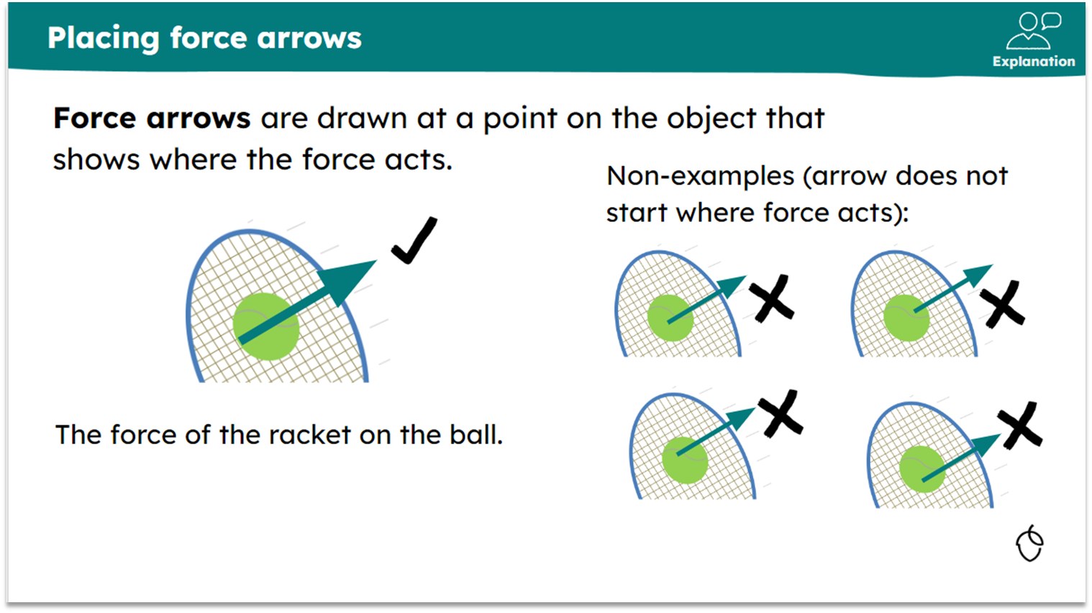  KS3 science |  |  | 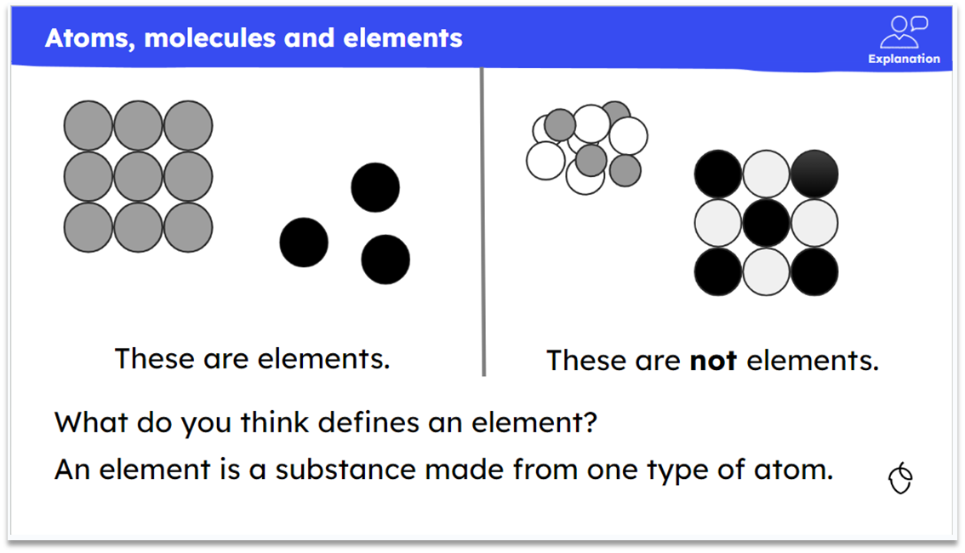  KS3 science
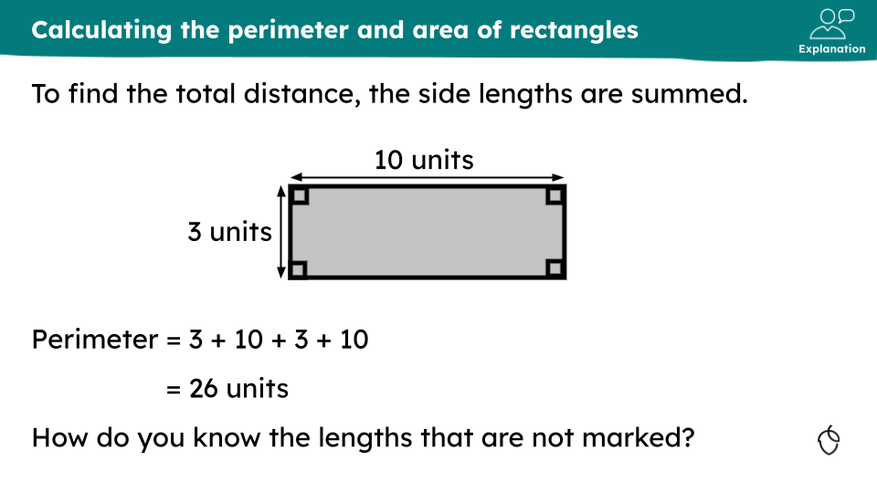  KS3 maths |  |  | 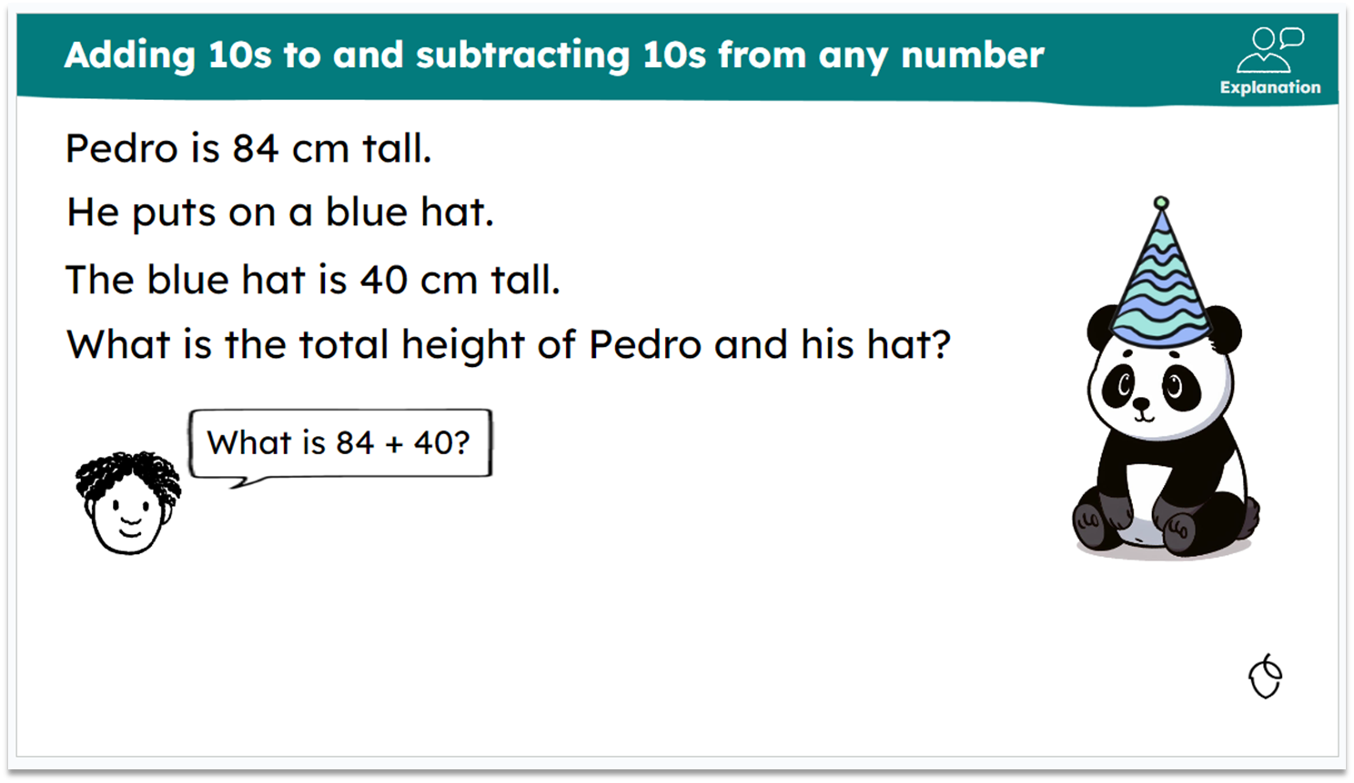  KS1 maths
further examples in The Library (available September 2024)

Images

Appropriately selected images support explanation because they help convey information in a visual and intuitive way. In essence, they help pupils build schema. Research has shown that when we use images to illustrate a concept or idea, we provide a visual representation that can make it easier for pupils to understand and remember the information. When accompanied with keywords and verbal narration, this reduces the redundancy effect.

In addition, images can help make complex information more accessible. By breaking down complex concepts into simpler visual representations, we can help pupils grasp the information more easily.

Furthermore, images can help capture pupils’ attention and engage them in the learning process. Visual stimuli can be more engaging and memorable than text alone, which will help pupils remain focused and retain the information more effectively. Further guidance on use of images can be found here.

✔ Examples  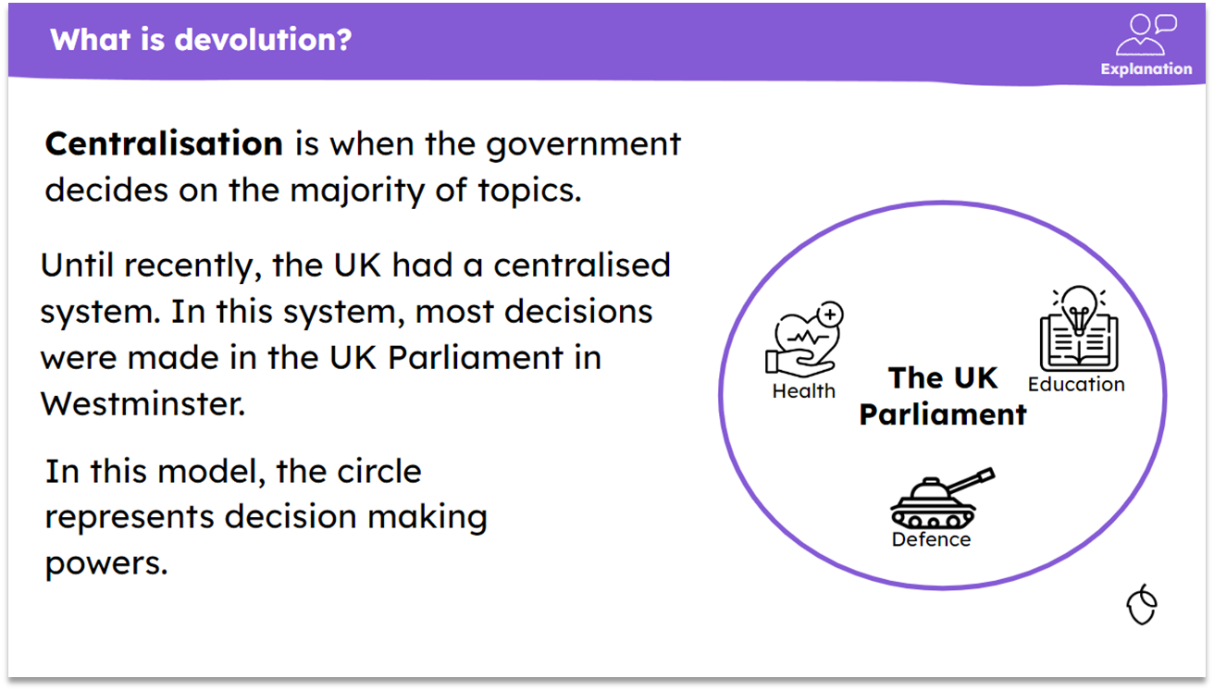  KS4 citizenship |  |  | 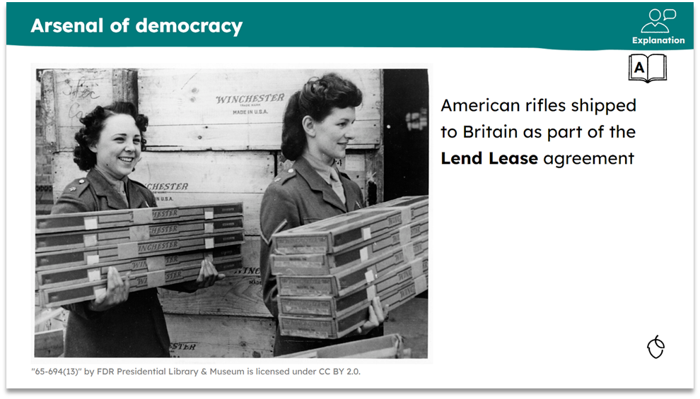  KS4 history
further examples in The Library (available September 2024)

Discussion

Discussion can support explanation in several ways. Firstly, it allows for a deeper exploration of the topic being discussed. When pupils engage in discussion, they can share their own perspectives, ask questions, and provide feedback, which can help clarify and refine the ideas being discussed.

Secondly, discussion can help pupils develop critical thinking and communication skills. By participating in a discussion, pupils can learn to analyse and evaluate different viewpoints, and express their own opinions clearly and persuasively. Engaging in this discussion can help create a sense of community and foster collaboration among pupils. When they engage in discussion, they can share their own experiences and learn from others, which can create a more supportive and engaging learning environment.

Thirdly, discussion can help pupils develop a deeper understanding of the material by connecting it to their own experiences and prior knowledge. When people discuss a topic, they can make connections between the material and their own lives, which can make the learning more relevant and meaningful.

Lastly, discussion can provide immediate feedback to pupils and give the teacher an opportunity to assess understanding. If pupils are struggling to understand a concept, they can ask questions and receive feedback from their peers and the teacher, which can help clarify misunderstandings.

- Oracy is developed throughout all subjects to help pupils become more effective speakers and listeners.

- A question to initiate discussion can be used on an explanation slide.

- Opportunities for discussion should be maximised to clarify explanation / address misconceptions.

✔ Examples 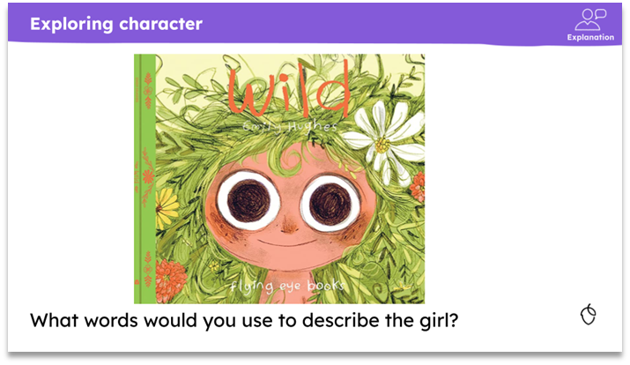  KS1 English |  |  | 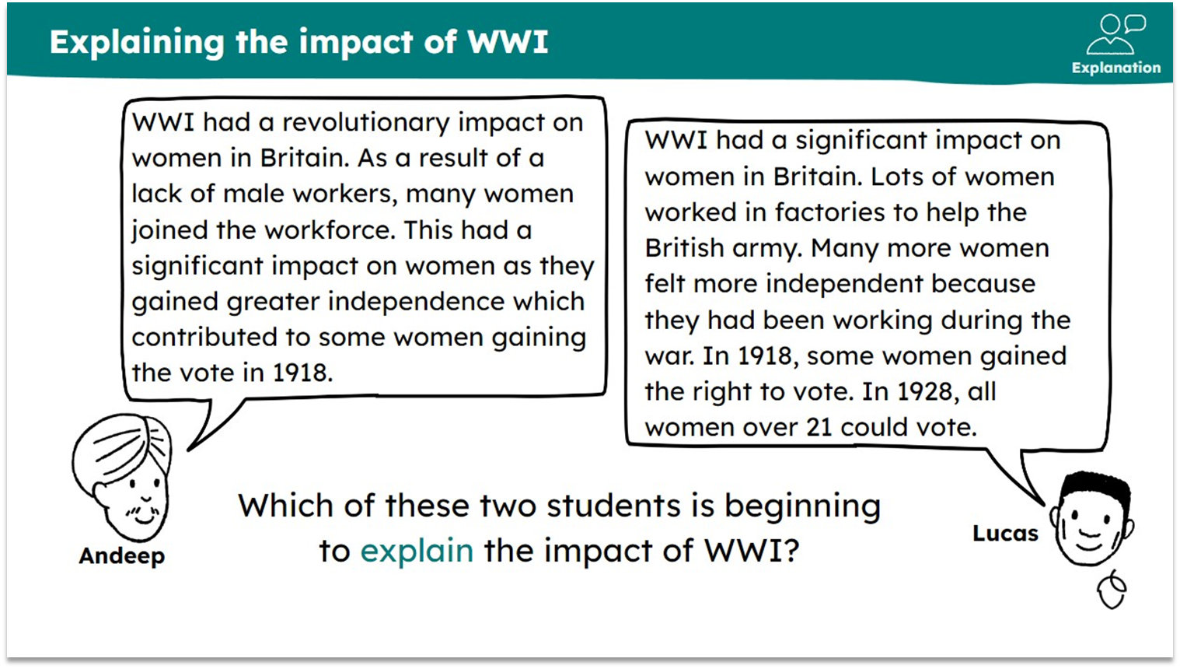  KS1 history
further examples in The Library (available September 2024)

Modelling and demonstration

Modelling is an instructional strategy in which the teacher demonstrates a new concept or approach to learning and students learn by observing. Demonstration is a practical exhibition and explanation of how something works or is performed.

Modelling and demonstration are powerful supports for explanation as they can provide worked examples of how to perform a task or use a concept in practice helping pupils to ‘get it’. When a teacher demonstrates a task, or how to approach it, pupils can see the process in action and understand the steps involved more clearly. Modelling and demonstration also help pupils build confidence in their own abilities. By watching someone else perform a task, and narrate what they are doing and why, pupils see it is possible to accomplish the task successfully, which can encourage learning.

Furthermore, modelling and demonstration help pupils understand how to apply a concept or skill in different contexts. By seeing the demonstration in action, pupils can identify the underlying principles and transfer them to new situations. In addition, modelling and demonstration support engagement and retention. Pupils create mental models that can help them remember the steps involved in processes.

Videoing modelling and demonstration has a number of details that require particular consideration. Remember in our welcome how we made reference to the approach to product development? This is one of those areas where we need a little longer to think this through really carefully. We shall look forward to providing you with training on this in due course.

Modelled answers are age appropriate in terms of grammar and language used.
✔ Examples  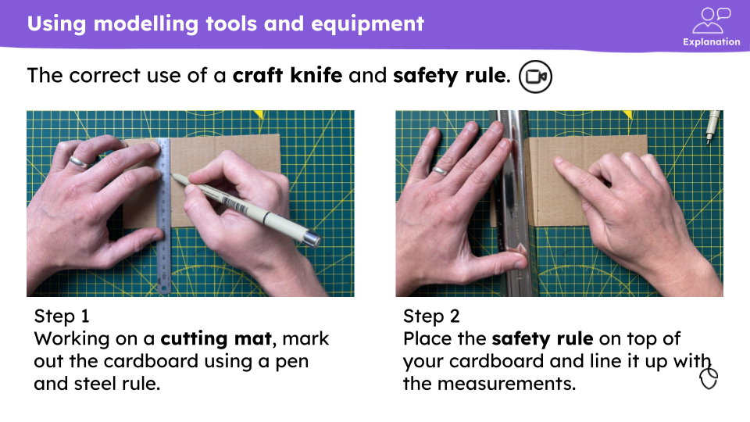  KS3 D&T |  |  | 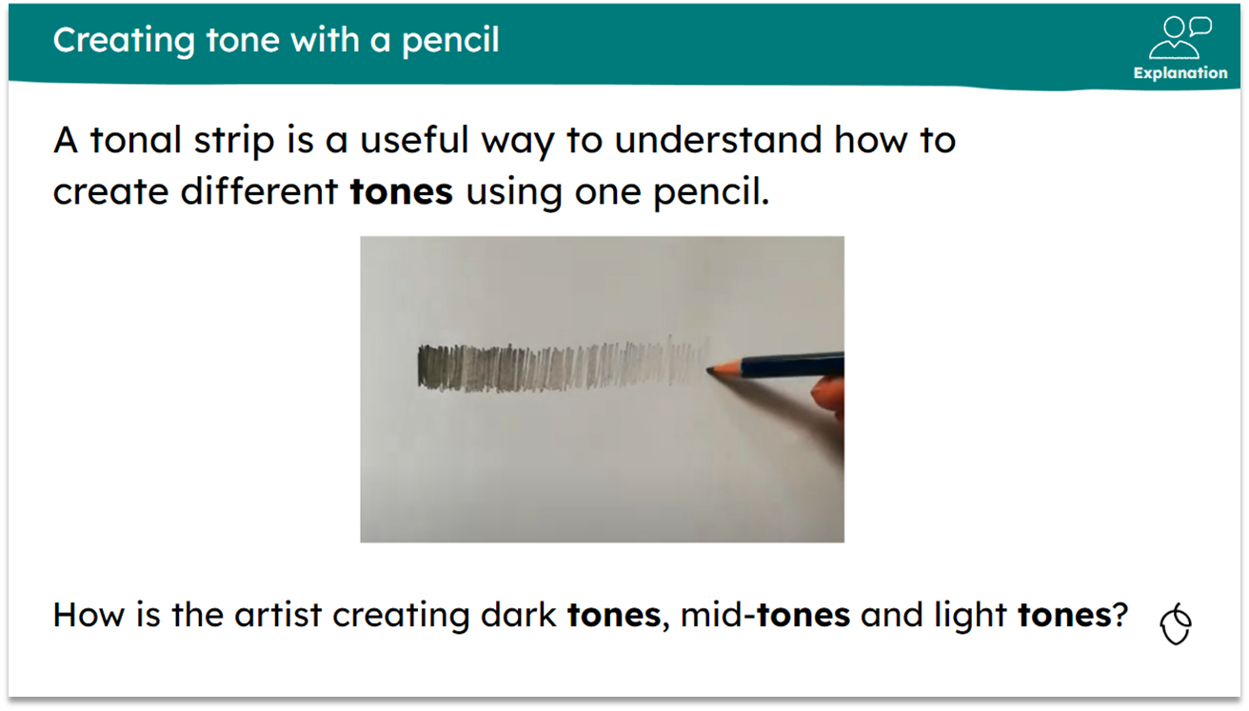  KS2 art & design
further examples in The Library (available September 2024)

Stories

Stories are the oldest method of passing down information. A good storyteller engages and enthrals. Even the youngest pupils understand how stories work. The enjoyment of stories does not age. Personal anecdotes, real-life context, tales of famous people and events can all be effective methods of exposition.

Stories help people engage emotionally and intellectually with a concept or idea. When you tell a story, you create a narrative that pupils can relate to and identify with. This can make it easier for pupils to remember and understand complex or abstract ideas.

In addition, stories can help create a memorable context for the concept or idea you are trying to explain. By using characters, settings, and events, you can create a vivid mental picture that can help pupils retain the information more effectively. This is because stories activate multiple parts of the brain, including the sensory and emotional centres, which can help encode the information more deeply.

✔Example

To explain empathy to a group of pupils we could use a story:

‘Once, I had a friend who was going through a really tough time. She had just lost her job, and she was really struggling. One day, we were talking on the phone, and she just started crying. I could hear how upset she was, and I felt for her. I wanted to help her, but I didn't know what to do. So, I just listened to her. I let her talk about how she was feeling, and I tried to understand what she was going through. I didn't try to solve her problems or offer advice, I just tried to be there for her and show her that I cared. In that moment, I realised that empathy isn't just about feeling sorry for someone. It's about putting yourself in someone else's shoes, trying to understand their perspective, and showing them that you care’.
further examples in The Library (available September 2024)

Analogies

Using analogies helps pupils access unfamiliar concepts and are a powerful way to move understanding from the concrete to the abstract. For example, referring to landscapes in
geography as books. Just as we read books, we can also read landscapes. Landforms and features of landscapes tell stories about their formation and we can divide these into chapters e.g. tectonic activity, glaciation and weathering.

NB Caution is required not to embed a misconception.
✔Examples
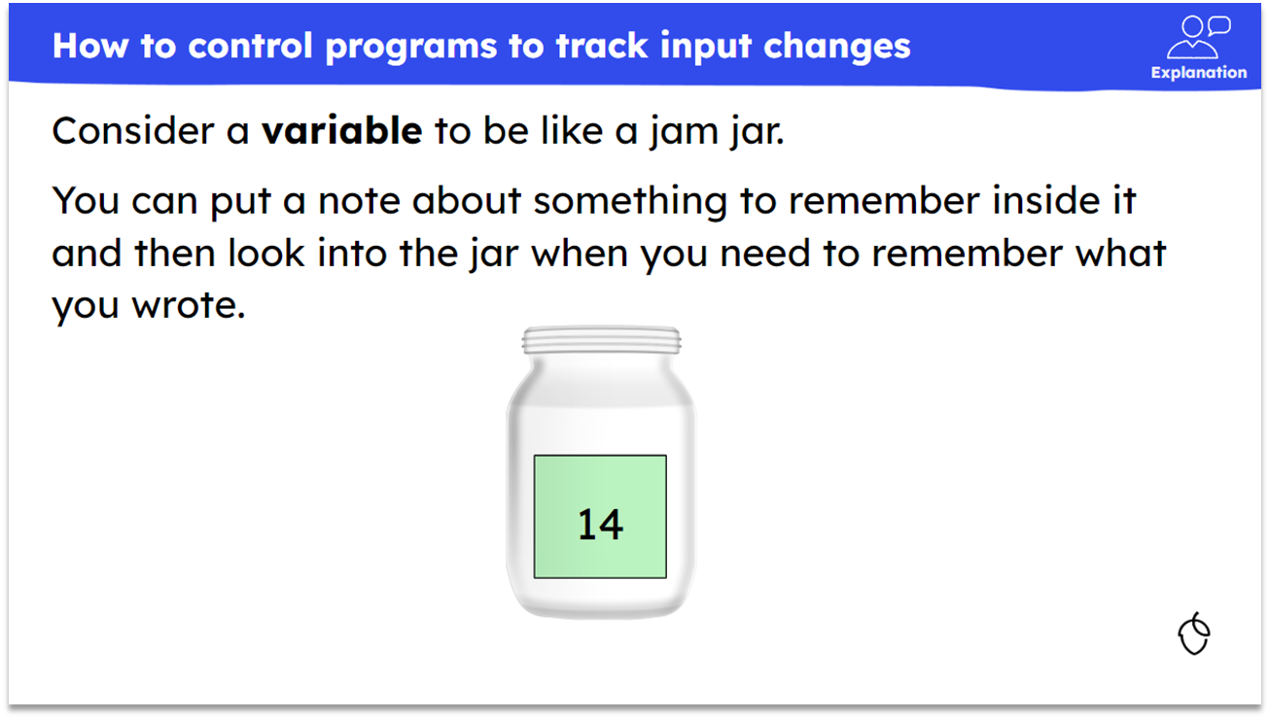  KS2 computing |  |  | 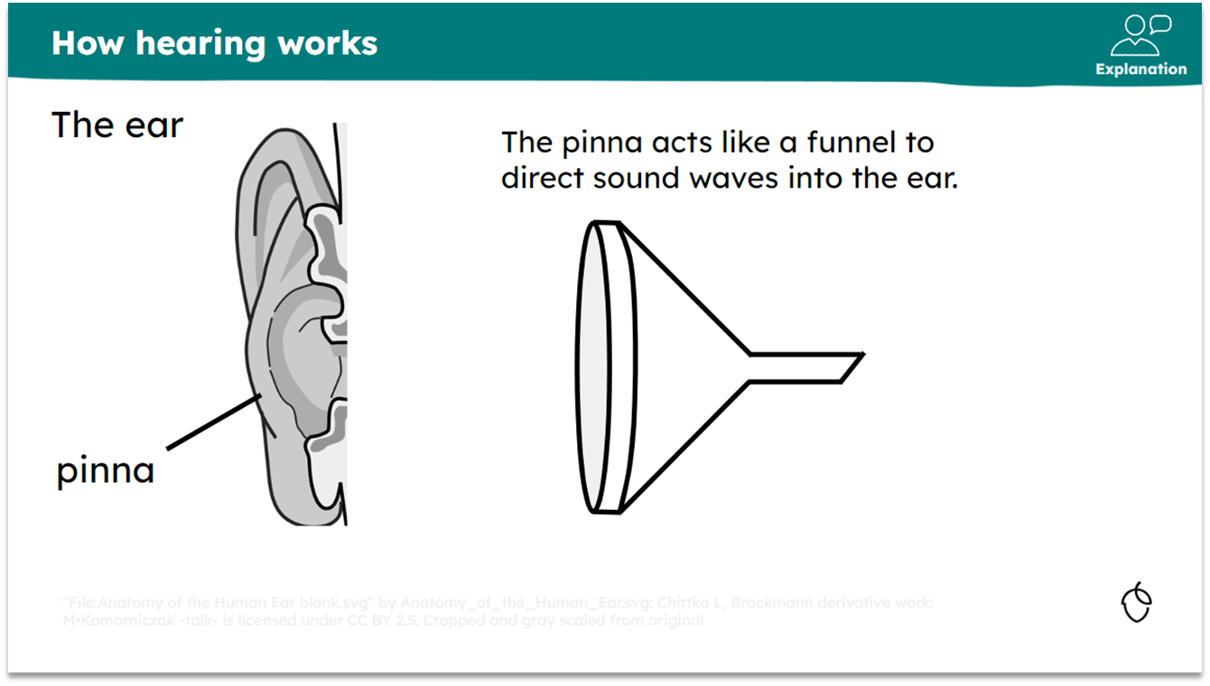  KS3 science
further examples in The Library (available September 2024)

Sweller, J. and Cooper, G.A., 1985. The use of worked examples as a substitute for problem solving in learning algebra. Cognition and instruction, 2(1), pp.59-89.
Pachman, M., Sweller, J. and Kalyuga, S., 2013. Levels of knowledge and deliberate practice. Journal of experimental psychology: Applied, 19(2), p.108.
Eggen, P., and Kauchak, D., 2001. Strategies for teachers: teaching content and thinking skills
Images from the nounproject

